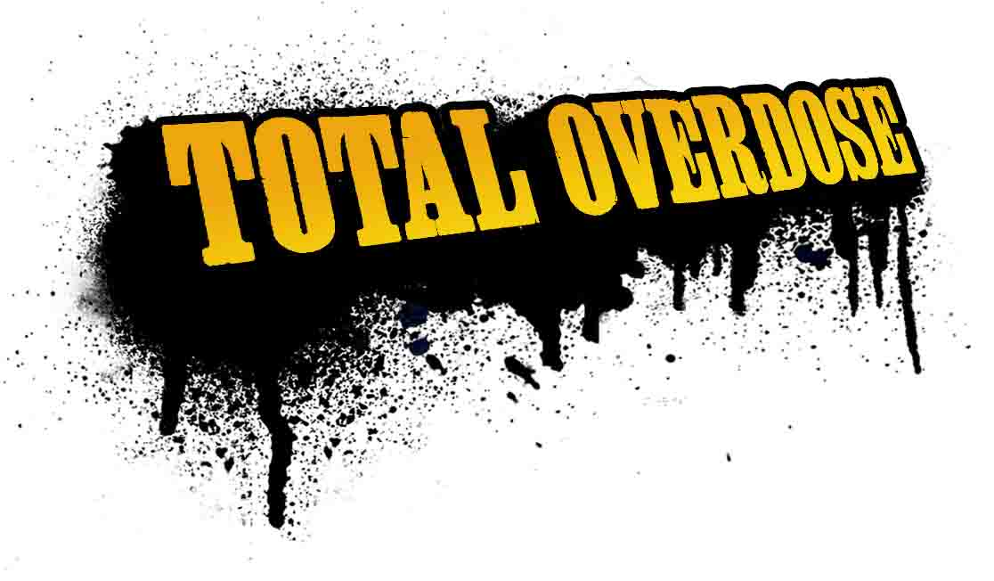

A super-cool, tequila-fuelled rampage through Mexico’s gun-toting, drug-pushing underworld. Go undercover with Ramiro Cruz ‘El Gringo Loco’, an ex-con, bad-ass fresh out of the joint and kicking up one hell of a Mexican storm.

Main features:

- A rich storyline taking the player through 18 different environments, from the seedy red light district of Los Toros to the depths of the Mexican desert.
- A free-style combat and stunt system to take down your enemy with more outrageous moves than you can shake a hot chilli at.
- Cutting-edge soundtrack featuring Molotov, Delinquent Habits and Control Machete.
- Uber-cool characters and missions with a strong whiff of tequila.
- Over 20 weapons: the better you get, the bigger your arsenal!
- Use the real-time rewind system to make perfect killa combos.
- Collect and win pickups to enable dual weapons and powerful loco moves
- Unique combo system earns the player rewards for stringing together multiple kills

